Given an n-ary tree, return the *preorder* traversal of its nodes' values.

*Nary-Tree input serialization is represented in their level order traversal, each group of children is separated by the null value (See examples).*

**Follow up:**

Recursive solution is trivial, could you do it iteratively?

**Example 1:**

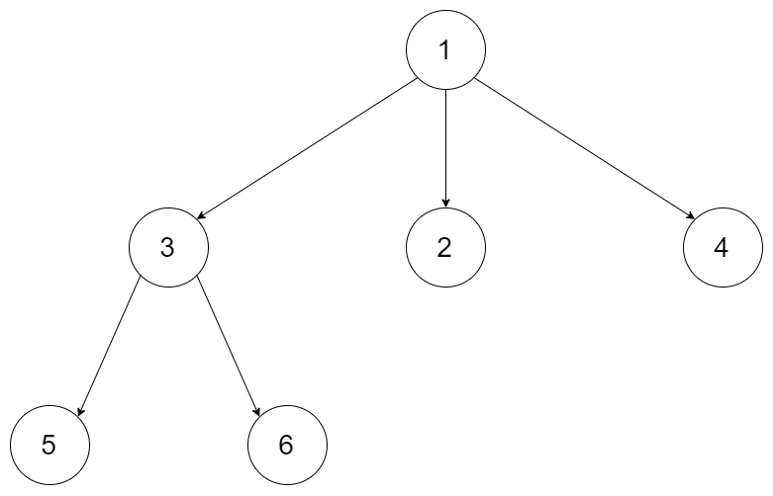

**Input:** root = [1,null,3,2,4,null,5,6]

**Output:** [1,3,5,6,2,4]

**Example 2:**

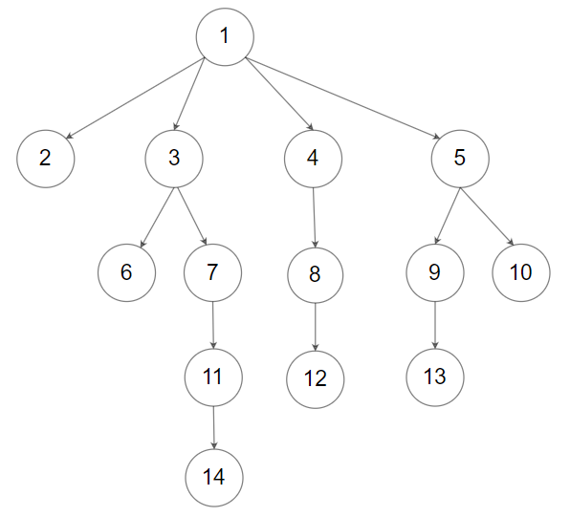

**Input:** root = [1,null,2,3,4,5,null,null,6,7,null,8,null,9,10,null,null,11,null,12,null,13,null,null,14]

**Output:** [1,2,3,6,7,11,14,4,8,12,5,9,13,10]

**Constraints:**

* The height of the n-ary tree is less than or equal to 1000
* The total number of nodes is between [0, 10^4]